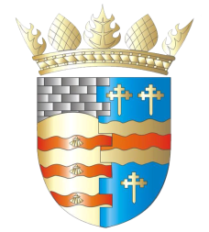**BLAIRGOWRIE AND RATTRAY COMMUNITY COUNCIL**

**Ordinary Meeting – Draft Agenda**

**Thursday, 12th June 2025, at 7pm**

**at the BaRI Building, High Street, Blairgowrie,**

**and online via Zoom**

1. Welcome and Introductions

2. Apologies

3. Adoption of draft minutes of 1st May 2025 meeting  
4. Police & Fire Reports

a) Riverside safety

5. Matters raised by members of the public

6. Representation of Young People

7. Regular reports

a) Resilience/Flooding/First Responders PR/SM

b) Climate Action DC/GP/JM

c) Twinning GP/SM/DC/AS

d) Maintenance in Blairgowrie & Rattray

i. Built Environment

a) Electrical Connections at Wellmeadow (B&R Common Good Fund?)

ii. Open Spaces

e) Local Place Plan

f) Citizen/Young Person/Group of the Year

7. Matters Arising/Reports Back

a) Emma Street laundry

b) Football Pitch

c) Gallowbank Footpath

8. Traffic Matters

a) Speeding Meeting

9. Planning Matters

10. Chair’s Report

11. Treasurer’s Report

12. Councillors’ Reports

13. AOCB

Please note: With the permission of all attendees, the minute taker will record this meeting solely for the purpose of writing up the minutes, will not share the recording, and will delete the recording as soon as the minutes have been written. The Chair will ask for permission at the start of the meeting.

Awaiting info: CCTV, Community Action Plan

**Next meeting: Ordinary Meeting, Thursday, 14th August 2025, 7.00pm**